RISK MANAGEMENT ANALYTICS  
  
  
ALY6130, SPRING 2021  
MODULE 5 PROJECT ASSIGNMENT

WEEK 5: Key Risk Indicators

SUBMITTED BY: SHIVANI ADSAR

NUID: 001399374

SUBMITTED TO: PROF. MICHAEL CAVALLO

DATE: 06/28/2021

**Introduction**

The assignment aims at identifying hypothetical Key Risk Indicators for the risks discussed in Assignment 2. Moreover, the assignment highlights the development of KRI’s using the concept of CRISP-DM, and then, provide the corresponding thresholds for every risk. This will help the store management in identifying potential risks and mitigate them.

**Analysis**

Risk Analysis

|  |  |  |  |  |
| --- | --- | --- | --- | --- |
| **Objective** | **Strategic Initiative** | **Potential Risks** | **Key Risk Indicators** | **Strategic Response** |
| Increase in revenue for store | Improve sales and marketing by promoting discounts | Major drop in the income levels of customers, which would prevent them from buying | Trends in highly demanded clothing designs by customers | Improve marketing techniques to promote more clothing patterns |
| Improve operational cost to the company | Hire highly skilled labor and improve production costs | Sharp increase in in house production costs | High performance of competitors in market | Improve and analyze costs spent on outsourcing projects and marketing |
| Maintaining data integrity | Adhering to the government compliance policies | Not keeping up with the data integrity policies | Advanced data security followed by competitors in market | Maintain and follow the data governance and compliance policies to ensure data integrity |

The below flow chart diagram shows the strategic initiative, potential risk and KRI involved for every task in order for the store to make profits

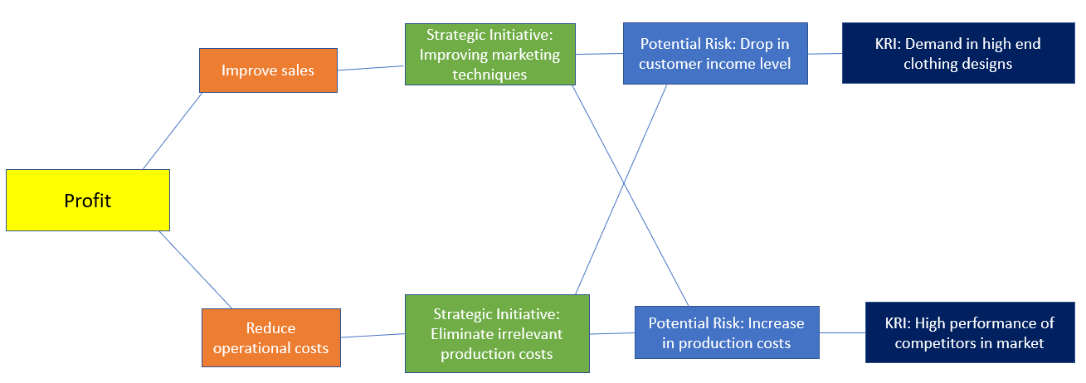

*Fig.1: Linkage Diagram : Objectives, Strategy and KRI*

CRISP-DM

The process stands for Cross-Industry Standard Process for Data Mining, which outlines some of the common processes used by companies in implementing their internal processes. It consists of the following modules:

Understanding the Business: This involves understanding the business requirements and gathering the data accordingly.

Understanding the Data: This involves analyzing the gathered data for further processing

Data Preparation: The data is then prepared to undergo data analysis and processing

Data Modelling: The data model is developed which suits the industry requirements

Evaluation: The developed data model is then evaluated

Model Deployment: The model is deployed for serving the clients needs and business requirements

It is important to identify and manage risks after every module and after every step of the entire CRIP-DM process.

Thresholds and Trigger Points:

* Risk 1: The store can lose its customers and become outdated if it does not keep in par with the latest clothing trends, therefore, the threshold for this risk is to carry out market analysis, and some trigger points could be dis-interest shown by the customers.
* Risk 2: The cost of infrastructure can lead to operational overhead for the company, and the threshold for the risk is to reduce marketing costs other operational overhead costs, and trigger points can be unskilled workers.

**Conclusion**

The assignment has helped in understanding techniques to analyze the Key Risk Indicators for various tasks within the organization. Moreover, the assignment has focused on understanding CRISP-DM process and ways in which the risks can be identified, by analyzing the thresholds and identifying triggers for every task.

**References**

*CRISP-DM*. Data Science Project Management. (2021, May 18). https://www.datascience-pm.com/crisp-dm-2/.

projectvictor.com. (n.d.). https://projectvictor.com/knowledge-base/risk-threshold/.